**1. POWER BI INTRODUCTION**

**ITEM #1: WHAT IS REPORTING?**

A MECHANISM TO ACCESS & PRESENT ANY TYPE OF DATA TO END USERS.

**ITEM #2: WHAT IS POWER BI?**

A SET OF TOOLS USED TO PERFORM END TO END REPORTING OPERATIONS.

THESE INCLUDE: DATA **EXTRACTION**, DATA **MODELING** AND **REPORTING.**

**MODELING MEANS TO RESHAPE OR FORMAT THE DATA. UNION, SORT, JOIN .........**

**ITEM #3: HOW IS POWER BI DIFFERENT FROM MSBI?**

**MSBI** : USED TO DESIGN DATABASES [90%] + USED TO DESIGN REPORTS [10%]

**POWER BI**: USED TO DESIGN REPORTS [100%] {Enterprise and Self Service BI}

**ITEM #4:** **WHAT ARE THE JOB ROLES WITH POWER BI? BUSINESS ANALYSTS / DATA ANALYSTS**

**ROLE 1: ACCESS ANY TYPE OF DATA, DESIGN REPORTS & PUBLISH TO CLOUD**

**ROLE 2 : ACCESS ANY TYPE OF DATA, DESIGN REPORTS & PUBLISH TO SERVER**

**ROLE 3: DESIGN DATASETS, DASHBOARDS, APPS & ROW LEVEL SECURITY (RLS)**

**ITEM #5:** **WHAT ARE THE LICENSING OPTIONS IN POWER BI?**

**\* 1. Power BI Free Trail {60 DAYS} : WE SHALL PROVIDE YOU THIS ACCOUNT**

**2. Power BI Pro : Costs about USD 9 per user per month**

**3. Power BI Premium : Costs ~ USD 14400 @ Organization Account**

**\* 4. Power BI Report Server : Free with SQL Server 2017 / 2019 LICENSE**

**ITEM #6: THE POSSIBLE DATA SOURCES THAT CAN BE USED WITH POWER BI?**

**File** Database **Azure** Others

----------------------------------------------------------------------------------------------------------------------------------------

• **Excel** • **SQL Server Database**  • Microsoft Azure SQL Database • Web

• CSV • **Access Database** • Microsoft Azure Synapse • SharePoint

• XML • **SQL Server Analysis Services** • Microsoft Azure Storage • OData Feed

• Text • Oracle Database • Microsoft Azure Data Lake • Hadoop File

• JSON • IBM DB2 Database • Microsoft Azure Cosmos DB • Google

• PDF • MySQL Database • Microsoft Azure Analysis Services • Facebook

**ITEM #7: DIFFERENT VISUALIZATIONS (REPORT SHAPES) IN POWER BI?**

|  |  |  |
| --- | --- | --- |
| 1. STACKED BAR CHARTS | 11. LINE, CLUSTERED COLUMN CHART | 21. GAUGE |
| 2. STACKED COLUMN CHARTS | 12. RIBBON CHART | 22. CARD |
| 3. CLUSTERED BAR | 13.WATERFALL CHART | 23. MULTICARD |
| 4. CLUSTERED COLUMN | 14. SCATTER CHART | 24. KPI |
| 5. 100% STACKED BAR | 15. PIE CHART | 25. SLICER |
| 6. 100% STACKED COLUMN | 16. DOUGHNUT CHART | 26. **TABLE** |
| 7. LINE CHART | 17. **TREEMAP** | 27. MATRIX |
| 8. AREA CHART | 18. MAP | 28. R SCRIPT VISUAL |
| 9. STACKED AREA | 19. FILLED MAP | 29. PYTHON VISUAL |
| 10. LINE, STACKED COLUMN CHART | 20. FUNNEL | 30. ArcGIS Maps |
| 31. KEY INFLUENCER | 32. DECOMPOSITION TREE | 33. Q & A |
| 34. ARCGIS MAP | 35. POWER APPS FOR POWER BI | ++ Customized Visuals |

**ITEM #8: WHAT ARE THE TYPES OF REPORTS ?**

|  |  |
| --- | --- |
| **1. INTERACTIVE REPORTS** | REPORTS ARE GENERATED BY DEVELOPERS. CAN BE EDITTED BY END USERS |
| **2. PAGINATED REPORTS** | REPORTS ARE GENERATED BY DEVELOPERS. CANNOT BE MODIFIED BY USERS |
| **3. ANALYTICAL REPORTS** | REPORTS ARE GENERATED USING **EXCEL** & **DAX** [DATA ANALYSIS EXPRESSION] |
| **4. MOBILE REPORTS** | REPORTS ARE GENERATED FOR MOBILES, TABLETS, SMART CLOCKS |

**ITEM #9: TOOLS USED IN POWER BI ?**

|  |  |  |
| --- | --- | --- |
| **REPORT TYPE (4)** | **TOOL USED FOR DESIGN (6)** | **PRODUCTION ENVIRONMENT (2)** |
| **INTERACTIVE REPORT** | POWER BI DESKTOP | POWER BI SERVICE (CLOUD) : PUBLIC |
| POWER BI DESKTOP RS | POWER BI REPORT SERVER : CORPNET |
| **PAGINATED REPORT** | POWER BI REPORT BUILDER | POWER BI SERVICE (CLOUD) |
| MICROSOFT REPORT BUILDER | POWER BI REPORT SERVER |
| **MOBILE REPORT** | MOBILE REPORT PUBLISHER | POWER BI REPORT SERVER |
| **ANALYTICAL REPORT** | EXCEL ANALYSER [Excel Add-In] | POWER BI SERVICE (CLOUD), SERVER |

**Power Query:** Used to **E**xtract Data from various sources

Perform Data **T**ransformations, **L**oad Data into Power BI Environment for Reporting

**DAX:** Data Analysis Expression Language

Used for Dynamic Data Reporting (Ex: Star Rating of Sales)

Used for Additional Reporting Computations, to implement Row Level Security (RLS)

**LAB PLAN**

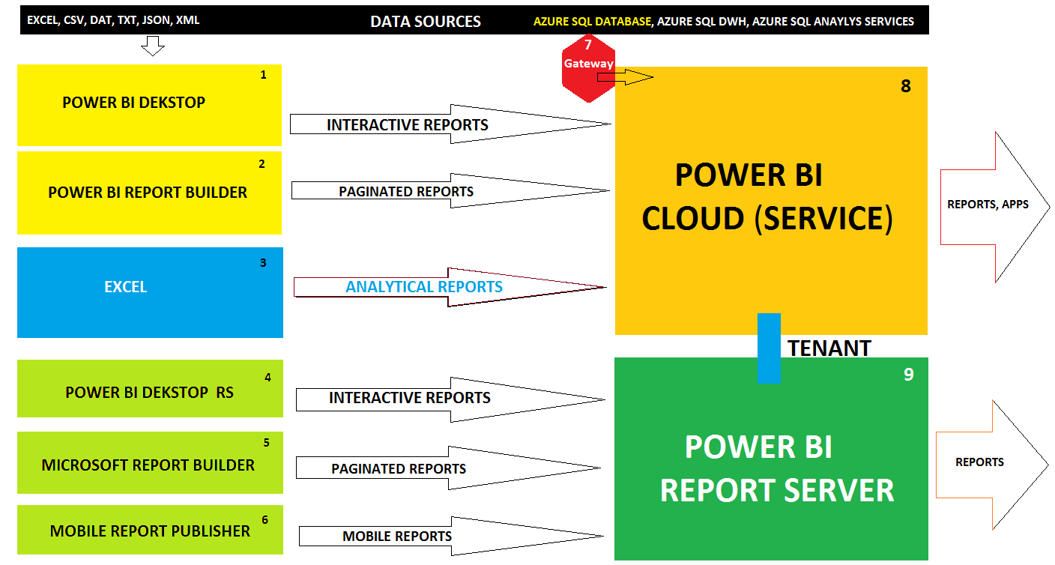

**Our Power BI Training Course Includes: 4 Weeks [Mon - Fri]**

|  |  |  |
| --- | --- | --- |
| **Module 1** [Visualizations] | **Module 2** [Power Query, DAX] | **Module 3** [Cloud Service, Server] |
| Power BI Report Design | **Power Query** For Data Modeling [M Lang] | **Power BI Cloud Service**, App Publish |
| Visual Interactions, Visual Sync | Power Query For ETL Operations & Models | Power BI Gateways, Data Flows |
| Grouping, Binning, Hierarchies | Power Query For Data Cleansing, Shaping | Alerts, Subscriptions, Workbooks |
| Drill-down & Drill-thru Actions | Power Query For Dynamic Data Extractions | Dashboards, REST API, Excel Online |
| Buttons, Bookmarks, Filters | Power Query For Dynamic Data Sources | Excel Analyzer and Excel Publisher |
| Visual Properties, Analytics | **DAX** For Calculated Columns & Measures | Power BI App Publish and Security |
| Data Modeling Options | DAX For Dynamic Data Reporting, Big Data | **Report Server** and Web Portal URL |
| Interactions and Navigations | DAX for Data Formatting and Joins | **Power BI Admin**, Mobile Reports |
| Custom Visualizations | DAX For Data Highlighting, End User Analysis | **Power BI Report Security Options** |
| Cloud Data Sets & Data Flows | DAX For Row Level Security, Azure Sources | **Power BI Tuning and Management** |
| **One Real-time Project For your Resume : Azure, SQL DB, CSV, TSV, Excel, and JSON Data Sources ++ Project FAQs** | | |

Software : We shall be providing you and guiding you for Installations.

**WIN 7 OR HIGHER. 32 bit** OR **64 bit. 4 GB RAM OR HIGHER**

Prior knowledge of SQL is recommended.

**DOWNLOAD LINK**: <https://aka.ms/pbiSingleInstaller>

CHOOSE ANY ONE FILE FROM ABOVE LINK [Either 32 bit or 64 bit] > DOWNLOAD.

DOUBLE CLICK ABOVE DOWNLOADED FILE > INSTALL > ACCEPT LICENSING TERMS > INSTALL.

RESTART YOUR COMPUTER

**MARKET: DATASOURCE**

**RAW VEGGIES : DATASET**

**POWER QUERY: KITCHEN [CLEAN. SLICING. DICING.COOK]**

**REPORT: RECIPE**

**DAX: TOPPING [PEPPER, SALT, CHEESE, ETC....] ++ RLS**

**REPORT: RECIPE**

**DASHBOARD: PLATTER OF RECIPES**

**APP: DELIVERY PARCEL**

**REPORT SERVER: ALA-CARTE, dine-in**

**ZOMATO/SWIGGY: CLOUD**